Shawn Shroyer | shroysha@gmail.com
(240) 310-8658 | https://www.shroysha.dev

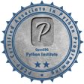 |  | 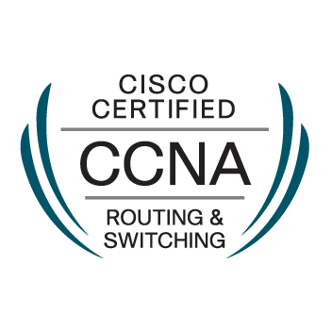 | 

Education
PCAP | Certified Associate in Python Programming | 2019
GSEC | GIAC Security Essentials Certification | 2015
CCNA | Cisco Certified Network Associate in Routing and Switching | 2015
ITIL | Axelos Information Technology Infrastructure Library v3 | 2015
Graduate of The Pennsylvania State University |  | 2015
- B.S. Information Sciences and Technology Major (Integration of Applications focus)
- Security and Risk Analysis Minor (Network Security focus)
GPA – 3.59, Dean’s List in all semesters, Academic Excellence in Information Sciences and Technology Award
Work Experience (9 years of programming experience – mainly hobby)
Software Engineer  Freelancing, Hagerstown, MD | 10/2016 – Present
- Experimented with machine learning in Python to successfully play the game 2048
- Created a VR app using C#, Unity, PHP, MySQL, and OAuth2, which displays user-created geographical content, using the devices’ location, gyroscopic angle, and compass data
- Used IntelliJ and implemented Gradle, MVC, Spring Boot, JUnit, and Lombok into my personal coding portfolio
- Created a Python modulo 29 number theory module in attempt to solve the 2015 Cicada 3301 puzzle

IT Support Specialist Level 3  The Pennsylvania State University, State College, PA | 01/2016 – 10/2016
- Moved to State College (post-graduation) and supported the Eberly College of Science’s Astronomy, Math, and Physics departments Linux research servers and their classroom and office Windows / Mac desktops
- Installed, packaged, and resolved issues with Anaconda, GCC, R Server, MATLAB, Maple, Mathematica, ArcGIS, and any other scientific software requested from researchers (some compiled from source)
- Lead and managed departments’ projects and assisted other departments as needed (primarily with Mac and Linux)
- Developed Bash, Python, and PowerShell scripts to automate daily tasks in SSH, SharePoint, and Active Directory

NOC Technician  TE Connectivity, Shirley, NY | 09/2015 - 10/2015
- Participated in a two week contract to assist the physical setup of a WAN NOC at an AT&T facility

Service Desk Technician | 06/2014 - 09/2015
National Institute of Standards and Technology (NIST), Gaithersburg, MD
- Worked full-time at a highly structured helpdesk providing user support to Gaithersburg and Boulder, while in college

Student Technician Supervisor  The Pennsylvania State University, Mont Alto, PA | 01/2013 - 06/2014
- Received promotion (from Student Technician) on 01/2014

please contact for more details and interview

